Defeating Malaria: The U.S. Leadership Role

Background
According to the latest WHO estimates, released in December 2016, there were 212 million cases of malaria in 2016 and 429,000 deaths—mostly children under the age of five in sub-Saharan Africa. While a child dies of malaria every two minutes, malaria is preventable and treatable; lives do not have to be lost to this disease. Insecticide-treated bed nets are the most cost-effective tool to prevent and control the spread of malaria.

Leading the way to a Malaria-Free world
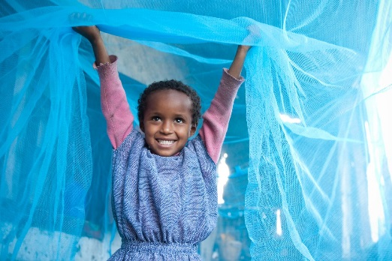
Due in large part to U.S. leadership and coordination with multilateral partners, including the UN and the Global Fund to Fight AIDS, Tuberculosis and Malaria, significant progress has been made in the fight against malaria. The UN World Health Organization estimates that increased prevention, control, diagnostic, and treatment measures reduced malaria incidence by 37 percent globally, reduced mortality rates by 60 percent, and saved an estimated 6.8 million lives from 2000-2015. Driving this progress, the U.S. President’s Malaria Initiative (PMI) and the Global Fund distributed more than 856 million bed nets and treated more than one billion malaria cases. During this time, 17 countries eliminated malaria.

The USG Response to Malaria
The primary organizations that the U.S. supports in the fight to defeat malaria are the President’s Malaria Initiative (PMI), housed at USAID, the Global Fund to Fight AIDS, Tuberculosis and Malaria (the Global Fund), and UN agencies. These organizations fund and lead malaria programs, strengthen health systems worldwide, and improve public health emergency response capacity.

Organization | FY15 Omnibus | FY16 POTUS Request | FY16 Omnibus | FY17 POTUS Request | FY17 House Approps Bill | FY17 Senate Approps Bill | FY17 Omnibus | FY18 POTUS Request
PMI | $669.5m | $674m | $674m | $874m | $845m | $774m | $775m | $674m
Global Fund | $1.35b | $1.106b | $1.35b | $1.35b | $1.35b | $1.35b | $1.35b | $1.125b
- Enacted in 2005 by President George W. Bush, the President’s Malaria Initiative (PMI) was established with a goal to reduce malaria deaths by half in 15 high-burden countries in sub-Saharan Africa. PMI’s proven success led to expansion under President Obama, and PMI’s 2015-2020 strategy continues work in the 19 PMI-supported countries with partners, including UNICEF and non-governmental organizations, to further reduce malaria deaths and substantially decrease malaria morbidity, towards the immediate goal of elimination.
- The Global Fund is the largest international financing institution created to raise resources to fight AIDS, tuberculosis, and malaria. While the Global Fund does not implement programs directly, it funds partnerships between national governments, civil society, local communities, and the private sector to design and carry out malaria programming. The Global Fund’s fifth replenishment conference in September 2016 raised $12.9 billion in funding pledges, with the U.S. maintaining it’s commitment to contributing one dollar for every two dollars pledged from other donor nations.
- Complementing the work of PMI and the Global Fund, the United Nations and its agencies also provide crucial malaria control, prevention and treatment services in some of the most dangerous and complex environments around the world. In the past seven years, UN agencies procured and distributed 188 million insecticide-treated nets, along with providing millions of Rapid Diagnostic Tests and treatments for malaria, serving as an indispensable partner to U.S. efforts.

