UTBM Virtual Advocacy Day | Training Worksheet
This worksheet is a companion to the provided Talking Points and is designed to help you organize and prepare for your meetings.
- LEADS: This worksheet is intended to help you structure and organize your group's efforts.
- CHAMPIONS: This worksheet is intended to support your individual preparation. This will help you organize your thoughts and key information.
PART 1: Introduction
Hi, my name is____________________________
I am from (STATE and DISTRICT) ________________________________
I am a United to Beat Malaria Champion because (This should be a one or two sentence statement about why beating malaria is important to you.)
_________________________________________________________________________________________________________________________________________________________________________________________________________________________________________________________________________________
- We are here today to talk about the fight against malaria and how these prevention activities not only save lives but also directly benefit America’s health, security, and prosperity.
- Ask about any familiarity the office has with malaria or global health–make it a conversation!

PART 2: Framing & Context
THIS SECTION WILL BE LED BY: ________________________________________
- We are grateful to Congress for the long-standing and strong bipartisan support for life-saving malaria programs including in the FY25 bills the House and Senate approved last summer.
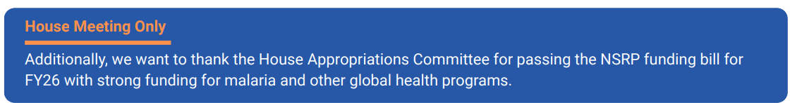
- U.S. leadership has helped drive significant progress against malaria the last twenty years, helping to save lives abroad and to protect us at home. Funding for these life-saving programs must continue to put an end to this entirely preventable and treatable mosquito-borne infectious disease.

PART 3: Why Malaria Prevention?
- Using the talking points, customize your message based on your research. You can deliver sections fully or partially, depending on what will be most effective.
- Assign roles within your group by deciding who will lead each section and present specific talking points.

- “THE PROBLEM” THIS SECTION WILL BE LED BY: ________________________________________
  - OPTIONAL: Suggestion to copy/ paste the specific text that will be delivered during meetings.

- “THE SOLUTION: Malaria Prevention Activities”
THIS SECTION WILL BE LED BY: ________________________________________
  - OPTIONAL: Suggestion to copy/ paste the specific text that will be delivered during meetings.
Part 4: Keeping America Safe
- Using the talking points, customize your message based on your research. You can deliver sections fully or partially, depending on what will be most effective.
- Assign roles within your group by deciding who will lead each section and present specific talking points.

- THIS SECTION WILL BE LED BY: ________________________________________
  - OPTIONAL: Suggestion to copy/ paste the specific text that will be delivered during meetings.

PART 5: Deliver the ‘Ask’
- Please note that the asks should be delivered by the constituent. Our asks will be different for House and Senate meetings.

- FUNDING ASKS | THIS SECTION WILL BE LED BY: ________________________________________
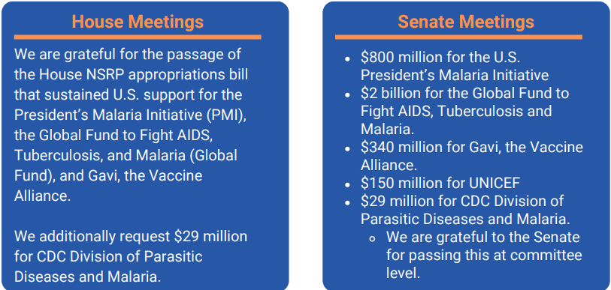
- Non-Programmatic Asks | THIS SECTION WILL BE LED BY: _________________________________
Please consider joining the Bipartisan Malaria and Neglected Tropical Disease Caucuses. Malaria intervention programs have historically seen robust bipartisan support, evidenced by investments in key programs and the leadership of our bipartisan and bicameral Malaria and Neglected Tropical Disease Caucuses.
Senate:
- Kendyl Willox (Sen. Wicker): Kendyl_Willox@wicker.senate.gov
- Katie Pannel (Sen. Coons): Katie_Pannell@coons.senate.gov
House:
- John McDonough (Rep. Smith): John.Mcdonough@mail.house.gov
- Emma Bruce (Rep. Bera): Emma.Bruce@mail.house.gov

PART 6: Offer Concluding Thoughts
Thank the staff for their valuable time and ask if they have any questions. If they ask a question you can’t answer, don’t worry! Let them know that they can contact Harsh Patel, Director, Global Health Advocacy: hapatel@betterworldcampaign.org

